**Enumerated Datatypes and Typedefs assignments**

Mandatory

**1. WAP to define an enum to store designations in an organization. List of possible values are**

**{E2F=1, E2, E3, E4, E5}**

Prompt and read a designation from the user. Then display his designation string such as

Designation Designation String

E2F Software Fresher

E2 Software Engineer

E3 Senior Software Engineer

E4 Team Lead

|  |  |
| --- | --- |
| Designation | Designation String |
| E2F | Software Fresher |
| E1 | Software Engineer |
| E2 | Senior Software Engineer |
| E3 | Team Lead |
| E4 | Senior Team Lead |

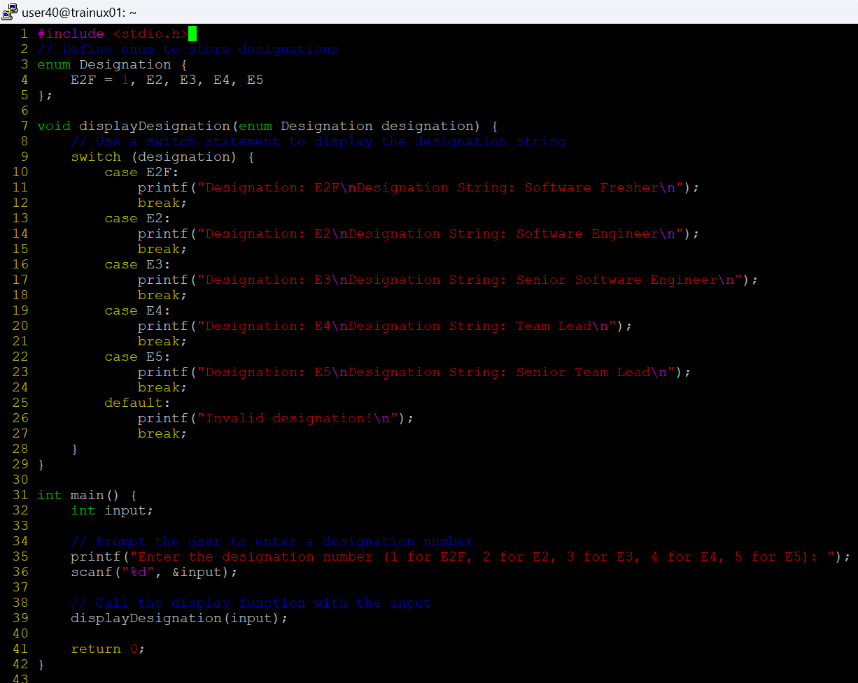

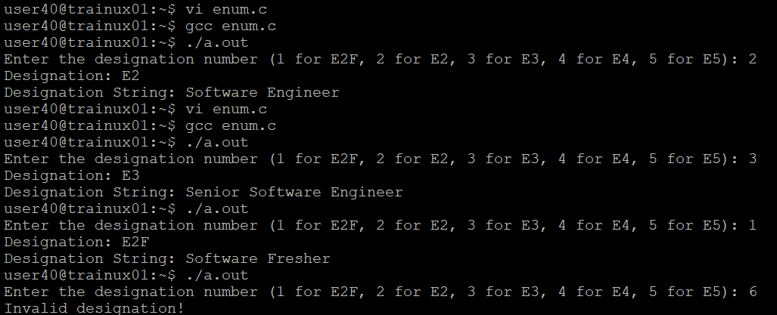

2. Define a typedef structure to keep the configuration of putty server. Identify and place all the required members. Create a structure variable and initialize it with user defined values and finally display the contents.



